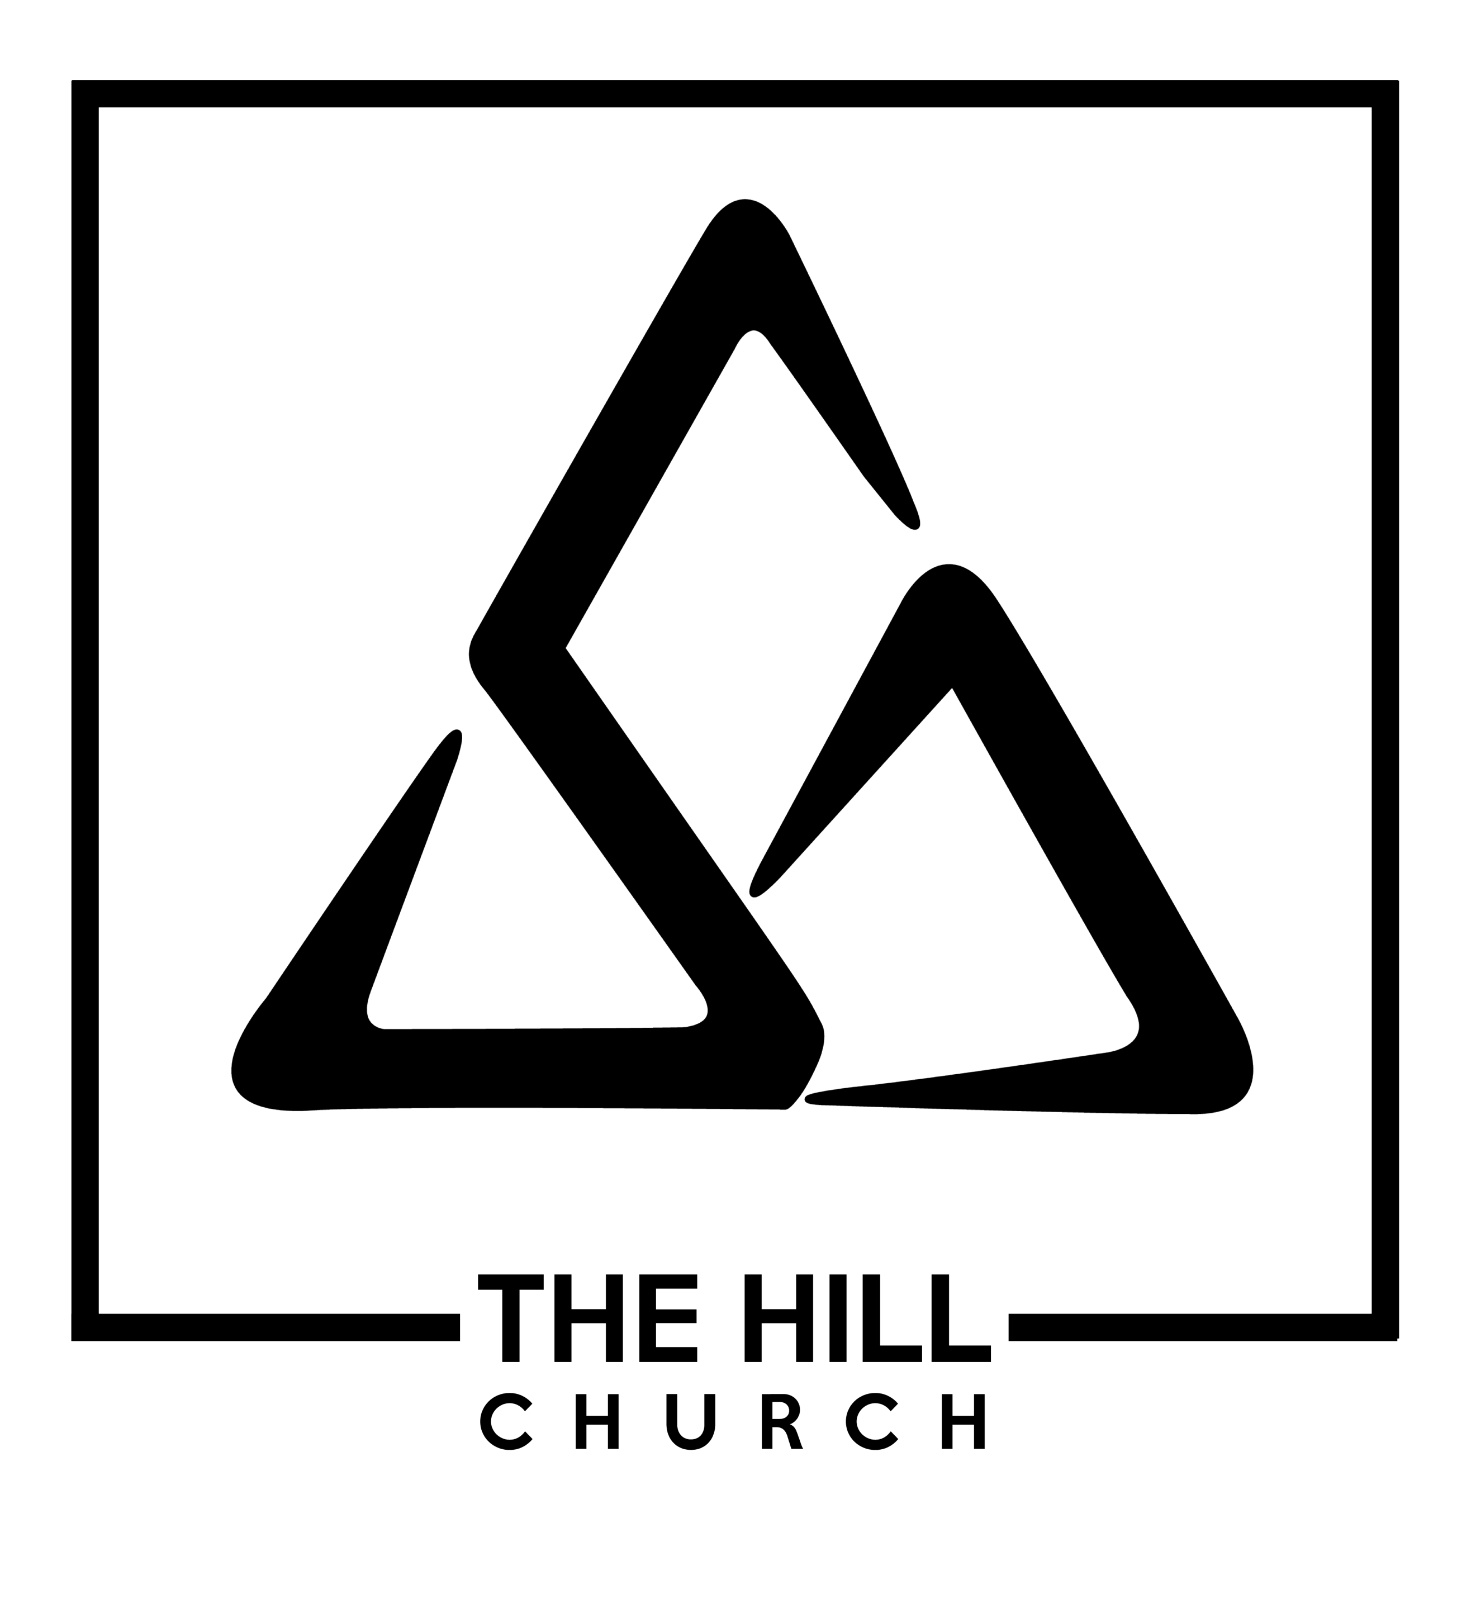

J-Term 2022

June-July Session

Systematic Theology

Why study Systematic Theology

- _________________________________
  - The objective in studying theology is _____________________________________
- _________________________________
  - We study theology so that the church can be _____________________
- ________________________________
  - “Truth fuels worship. Theology sparks doxology. It’s good to ask, if our worship feels shallow, could it be because we have shallow theology? Without theology there is no fuel to the fire of our worship. Enduring heat doesn’t come by seeking more sparks (motivational speaker, cool new conference, great musical sound). Enduring heat comes as we pour the truth of God’s words into our souls. What God’s people most fundamentally need is a grand vision of God!” (Dagg’s Manual of Theology, 13)
- _________________________________
  - Jn. 8:31; 2 Tim. 4:3-4
  - We need to hold to Jesus’ teaching, but we also need to clarify what Jesus and the Bible _________ teach

Key Features of Systematic Theology
- ___________________
  - The Bible alone is the ____________ and ______________ Word of God
- ___________________
  - We can’t do theology in a ___________
- ___________________
  - Systematic theology isn’t _________, ___________, and ______________
- _________________ (Col. 1)
  - Dead orthodoxy is not __________ orthodoxy
  - Rev. 3:1 – True theology is ____________________

Doctrine of the Word

The Bible alone is to be our __________ ________________ when it comes to the Christian faith.

Two Presuppositions to maintain throughout:
- __________________________- (triune, sovereign and personal)
- __________________________

That God both __________ and _____________ is in fact one of the primary ways the Bible distinguishes the true God form all other false gods ( 1 Kings 18:24; Ps 115:5; Hab. 2:18-20)

The word of God would include the power by which God brings all things to pass according to the ________________________- (Eph. 1:11)

To _________ God’s word is to ________ God, to __________ his word is to __________ him (Is. 66:2)

____________ is God’s free gift to us.

One of the key forms that revelation takes is __________________, God’s ____________ _________ committed to writing.

The Case for the Bible as our Authority

The Bible as God’s authoritative word pervades the entire scriptures.

Old Testament

In entering into a covenant relationship with Israel, God gave people his __________ (Deut. 5:22, Deut. 32)

The fact that man penned the words never affected the reality that their ___________ and _______________ were divine (Rom. 3:2; Actus 4:25, 28:25; Heb. 3:7, 8:8, 10:15)

“Thus says the Lord” from a prophet is ________________ to God speaking directly.

New Testament

Jesus treated the OT scriptures as _________ _______________. (Matt. 5:17, Jn. 10:35)

Jesus _________ by the scriptures.
The NT testifies to the authority of the OT and recognizes its own authority on _____with the OT. (Jn. 16:12-15; 1 Cor. 2:13; 2 Pet. 3:16; 1 Tim. 5:18)
  - The OT and NT attests to the ___________ as God’s authoritative revelation to his people.
  - The Bible comes to us in a __________ __________.

Canon:
OT Canon

OT is traditionally divided into the ______, __________, ___________. These books were recognized in Judaism as belonging together and constituting God’s verbal revelation to his people.

The OT canon was a __________ ___________ among the Jews of Jesus’ day.

Apocrypha: inspirational, devotional writings bound alongside the Greek translation of the OT hundreds of years later, but never were referred to as Scripture, the very words of God.

NT Canon

The pattern in the OT: God acts and then provides the ______________ of those actions for us through the _______ ___________. It was the same with the coming of Christ.

There is a ________ impression that the church took a long time recognizing the authority of the NT documents (Council of Carthage 397 AD), but there is an important distinction between _________ the authority of the book and drawing up a list that includes the book.

The 27 NT books had been widely circulated for ____________ and been treated as Scripture from the _____________.

The NT books are “the _________ Christian writings that have been confidently dated to the first century” ( Greg Gilbert, Why Trust the Bible?, 64)

How do we know that the gospels in the Bible are the most original documents?
- Early believers cared about the truth and defended in their letters because the books of the NT are _______________

Gnostic gospel:

Alternate texts that attempt to __________ the gospel format, but present a ________ __________ message.
- Scripture is ________ - __________ : it affirms and teaches to its own truthfulness

Criterion for Acceptance of Legitimate Books

It’s important to note that early Christians did not see themselves as “choosing” or “deciding” the books of the Bible, rather they spoke of “__________” or “___________” the authoritative books from each previous generation.
- Apostolicity: document was written by an ____________ or someone with ___________ __________ to an apostle.
- _________: the book had to be known to originate from the time of the apostles.
- Conformity to the Rule of Faith (________________): a book had to be consistent and conform to the truth already given
- Universality: ________ and _____________ usage by the churches across the known world. There was much _____________ on many books quickly.

Implications

The church didn’t ________ the Bible by its authority. The Bible possessed its _________ authority as God’s word and God’s word brought life to the church.

As the OT ended in anticipation of Christ’s first coming, so the NT closes with anticipation of his ________.

Resources
Wayne Grudem, Systematic Theology
John L. Dagg, Manuel of Theology
JI Packer, Concise Theology
Tim Challies, Visual Theology
Daniel B. Wallace, Revisiting the Corruption of the New Testament
Michael Kruger, “The Biblical Canon” (https://www.thegospelcoalition.org/essay/the-biblical-canon/)

